**Online Resume Builder**

Introduction

In this Java project tutorial, we will learn how to develop a CV builder using Java that creates a Resume pdf for the information given by the user. In today’s job market, having a strong and well-crafted resume can make all the difference in securing your dream job. However, creating a personalized and professional CV can be a daunting task, especially if you’re starting from scratch. That’s where a CV builder comes in handy.

With the help of Java, you can create your own CV builder that can generate a customized resume with ease. In this project tutorial, we’ll guide you through the process of developing your own CV builder using Java, so you can stand out from the competition and land your dream job.

We will be using swing to implement the GUI of our CV builder and provide the functionality to create & edit a pdf file with data captured

**Requirements**

To develop a resume builder using Java, it is recommended that you have the following prerequisites:

1. Basic knowledge of Java programming language, including object-oriented programming concepts such as classes, objects, methods, and inheritance.

2. Familiarity with Java Development Kit (JDK) and Integrated Development Environment (IDE), such as [**IntelliJ IDEA**](https://www.jetbrains.com/idea/) or NetBeans.

3. Understanding of graphical user interface (GUI) design principles and experience with GUI toolkits, such as Swing or JavaFX. We have used Java’s Swing framework as it has several components that give developers the freedom and flexibility to create eye-catching interfaces for Windows-based applications. Also, the best thing about using Swing module to create components like tables, scrollbars and buttons is that the framework is platform independent & Apache iText is an open-source Java library that supports the development and conversion of PDF documents.

4. Knowledge of data structures, such as arrays and linked lists, and their implementation in Java.

5. Familiarity with file handling and input/output operations in Java.

6. Awareness of resume writing and formatting guidelines to ensure the resume builder generates a professional-looking resume.

**Source Code**

**Main.java**

**package** com company;

**public** **class** Main {

**public** **static** **void** main(**String**[] args) {

new CV();

}

}

**CV.java**

**package** com.company;

**import** com.itextpdf.text.BaseColor;

**import** com.itextpdf.text.Document;

**import** com.itextpdf.text.FontFactory;

**import** com.itextpdf.text.Paragraph;

**import** com.itextpdf.text.pdf.PdfPTable;

**import** com.itextpdf.text.pdf.PdfWriter;

**import** javax.swing.*;

**import** javax.swing.filechooser.FileNameExtensionFilter;

**import** java.awt.*;

**import** java.awt.event.ActionEvent;

**import** java.awt.event.ActionListener;

**import** java.io.File;

**import** java.io.FileOutputStream;

**public** **class** CV {

**private** JPanel cvPanel;

**private** JTextField name;

**private** JTextField address;

**private** JTextField contact;

**private** JTextField email;

**private** JTextField skills1;

**private** JTextField skills2;

**private** JTextField skills3;

**private** JTextField skills4;

**private** JComboBox work;

**private** JTextField college;

**private** JTextField qualiA;

**private** JButton SELECTIMAGEButton;

**private** JLabel img;

**private** JButton GENERATERESUMEButton;

**private** JTextField qualiB;

**private** JTextField location;

JFrame frame = new JFrame();

**public** CV() {

frame.setDefaultCloseOperation(JFrame.EXIT_ON_CLOSE);

frame.setContentPane(cvPanel);

frame.pack();

frame.setLocationRelativeTo(**null**);

frame.setVisible(**true**);

SELECTIMAGEButton.addActionListener(new ActionListener() {

@Override

**public** **void** actionPerformed(ActionEvent e) {

JFileChooser fileChooser = new JFileChooser();

FileNameExtensionFilter filter = new FileNameExtensionFilter("*.IMAGE","jpg","png");

fileChooser.addChoosableFileFilter(filter);

**int** rs = fileChooser.showSaveDialog(**null**);

**if**(rs==JFileChooser.APPROVE_OPTION){

File selectedImage = fileChooser.getSelectedFile();

location.setText(selectedImage.getAbsolutePath());

img.setIcon(resize(location.getText()));

}

}

});

GENERATERESUMEButton.addActionListener(new ActionListener() {

@Override

**public** **void** actionPerformed(ActionEvent e) {

**if**(name.getText()==**null**||contact.getText()==**null**||address.getText()==**null**||email.getText()==**null**){

JOptionPane.showMessageDialog(**null**,"PLEASE ENTER ALL DETAILS TO GENERATE CV");

}**else**{

**try** {

**String** nameOfFile = "D:\\PDFYAHA\\my.pdf";

Document myDocument = new Document();

PdfWriter.getInstance(myDocument, new FileOutputStream(nameOfFile));

myDocument.open();

com.itextpdf.text.Image img = com.itextpdf.text.Image.getInstance(location.getText());

img.setAbsolutePosition(473f, 750f);

img.scaleAbsolute(80f,70f);

PdfPTable table = new PdfPTable(2);

myDocument.add(img);

myDocument.add(new Paragraph(name.getText(),FontFactory.getFont(FontFactory.TIMES_BOLD,32, com.itextpdf.text.Font.BOLD,BaseColor.DARK_GRAY )));

myDocument.add(new Paragraph("",FontFactory.getFont(FontFactory.TIMES_BOLD,9,BaseColor.DARK_GRAY)));

myDocument.add(new Paragraph("",FontFactory.getFont(FontFactory.TIMES_BOLD,9, BaseColor.DARK_GRAY)));

myDocument.add(new Paragraph("----------------------------------------------------------------------------------------------------------------------------------"));

myDocument.add(new Paragraph("CONTACT DETAILS",FontFactory.getFont(FontFactory.TIMES_BOLD,9, com.itextpdf.text.Font.BOLD,BaseColor.DARK_GRAY )));

myDocument.add(new Paragraph(email.getText(),FontFactory.getFont(FontFactory.TIMES_BOLD,7,BaseColor.DARK_GRAY )));

myDocument.add(new Paragraph(contact.getText(),FontFactory.getFont(FontFactory.TIMES_BOLD,7,BaseColor.DARK_GRAY )));

myDocument.add(new Paragraph(address.getText(),FontFactory.getFont(FontFactory.TIMES_BOLD,7, BaseColor.DARK_GRAY )));

myDocument.add(new Paragraph("----------------------------------------------------------------------------------------------------------------------------------"));

myDocument.add(new Paragraph("SKILLS",FontFactory.getFont(FontFactory.TIMES_BOLD,9, com.itextpdf.text.Font.BOLD,BaseColor.DARK_GRAY )));

table.setHeaderRows(1);

table.addCell(skills1.getText());

table.addCell(skills2.getText());

table.addCell(skills3.getText());

table.addCell(skills4.getText());

myDocument.add(table);

myDocument.add(new Paragraph("----------------------------------------------------------------------------------------------------------------------------------"));

myDocument.add(new Paragraph("QUALIFICATIONS", FontFactory.getFont(FontFactory.TIMES_BOLD,9, com.itextpdf.text.Font.BOLD, BaseColor.DARK_GRAY )));

myDocument.add(new Paragraph(college.getText(),FontFactory.getFont(FontFactory.TIMES_BOLD,7,BaseColor.DARK_GRAY )));

myDocument.add(new Paragraph(qualiA.getText(),FontFactory.getFont(FontFactory.TIMES_BOLD,7,BaseColor.DARK_GRAY )));

myDocument.add(new Paragraph(qualiB.getText(),FontFactory.getFont(FontFactory.TIMES_BOLD,7,BaseColor.DARK_GRAY )));

myDocument.add(new Paragraph("----------------------------------------------------------------------------------------------------------------------------------"));

myDocument.add(new Paragraph("WORK EXPERIENCE",FontFactory.getFont(FontFactory.TIMES_BOLD,10, com.itextpdf.text.Font.BOLD,BaseColor.DARK_GRAY )));

myDocument.add(new Paragraph(""+work.getSelectedItem(),FontFactory.getFont(FontFactory.TIMES_BOLD,7,BaseColor.DARK_GRAY)));

myDocument.add(new Paragraph("----------------------------------------------------------------------------------------------------------------------------------"));

myDocument.add(new Paragraph("REFERENCES",FontFactory.getFont(FontFactory.TIMES_BOLD,9, com.itextpdf.text.Font.BOLD,BaseColor.DARK_GRAY )));

myDocument.add(new Paragraph("Available upon request",FontFactory.getFont(FontFactory.TIMES_BOLD,6,BaseColor.DARK_GRAY )));

myDocument.close();

JOptionPane.showMessageDialog(**null**,"CV was successfully generated");

}

**catch**(Exception ex){

JOptionPane.showMessageDialog(**null**,ex);

}

}

}

});

}

**public** ImageIcon resize(**String** path){

ImageIcon myImg = new ImageIcon(path);

Image image = myImg.getImage();

Image newImage = image.getScaledInstance(200,200,Image.SCALE_SMOOTH);

ImageIcon finalImage = new ImageIcon(newImage);

**return** finalImage;

}

}

**Output**

**Main Interface**

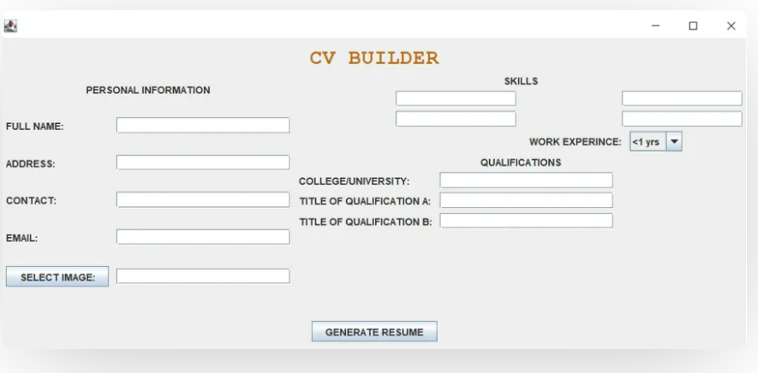

We have successfully developed a CV builder using Java that helps to generate a PDF file of Person’s CV with Swing used for GUI. This is a very efficient way to use the application to create a good looking resume in the pdf format.